81st LCA Discussion Forum
Thursday, 15. September 2022

DF 81: How to harmonize and compare LCA in the service industry

Location of this DF LCA: Wädenswil, Campus Grüental, Aula in GA 203

The official language of this event is English
The service industries – e.g., finance, insurance, health care, tourism, transport, resource trade or telecom – are together responsible for 75 % of GDP in both the European Union and in Switzerland. Despite its economic relevance, existing initiatives like the Product Environmental Footprint (PEF) and Organisational Environmental Footprint (OEF) of the European Commission do not focus on services, but on standardised rules for product groups and sectors. With the global economy continuously shifting to more service than product-oriented business models, it is crucial to also address service industries and their specific challenges related to environmental assessment.
In the case of service industries, fundamental questions for LCA, like the choice of functional unit or the definition of the system boundaries, are considerably more challenging compared to products or organisations. As an example, it is extremely difficult to reasonably quantify health services: How can different treatments be compared and their positive impact on health be quantified? Another example is the finance sector: What is the functional unit of financial advice? Which system boundaries should be chosen when assessing the impact of a bank and their investment portfolio?
This discussion forum will provide an insight into the LCA related challenges of different service providers, focusing on health care, banking & finance, as well as public services, and open the discussion on specific challenges encountered when doing an LCA of services.
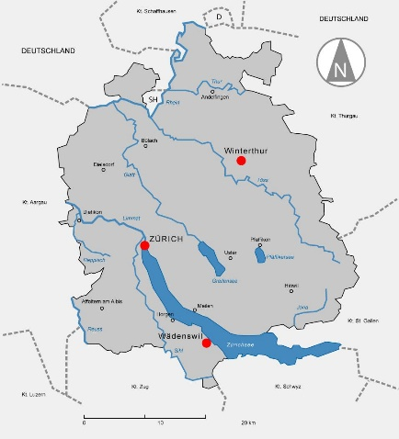
Furthermore, this forum will provide a platform to discuss new modelling approaches for the comparison of services and the importance of induced effects, e.g., caused by investments, and other indirect effects like rebounds tied to functional units and system boundaries for services.
We look forward to welcoming you at the Campus Grüental in Wädenswil.

Regula Keller, René Itten and Matthias Stucki,
Zurich University of Applied Sciences (ZHAW)

Preliminary Programme (as of 19.8.2022)
Time | Session | Speaker [Chair]
08:30 | Registration and welcome | (Barbara Dold, Regula Keller)
08:45 | LCA and the Service Industry – an Introduction | [Regula Keller]
08:50 | The service industry, its role for the national environmental footprint and challenges for analysis | Isabell O’Connor / Andi Spörri, Ernst Basler Partner
09:15 | Banking and Financial Services | [René Itten]
09:15 | Environmental Footprint of ABS’s service portfolio: approaches used and results | Markus Ott, ABS (tbc)
09:35 | Environmental Footprint of Financial Services | (tbc)
09:55 | Discussion
10:10 | Coffee Break
10:40 | Health Care Services | [Matthias Stucki]
10:40 | Applying LCA to health care: the care pathway approach | Rodrigo Alvarenga Senior Consultant, ERM
11:00 | Comparing health services: Advantages and disadvantages of different approaches | Regula Keller, ZHAW
11:20 | Public Services – Approaches of Cities | [René Itten]
11:20 | Life cycle assessment of public services in the city of Zurich: Approaches and strategy | Rainer Zah, Stadt Zürich
11:35 | Climate Plan of the City of Lausanne: approaches to estimate the GHG emissions | Denis Bochatay, Quantis
11:50 | Discussion
12:05 | Lunch Break
13:20 | Short Presentations | [Matthias Stucki]
13:20 | Biodiversity impact of financial institutions | Daniël Kan, Pré Sustainability
13:30 | Comparing cleaning services: Change of results for different functional units | Maria Kravchenko, Sustainability Consultant at SustainX (tbc)
13:40 | tbd
13:50 | Discussion
14:05 | Coffee Break
14:35 | Modelling Approaches & Rebound Effect in the Service Industry | [Regula Keller]
14:35 | Business-Model LCA for services: Comparing the impact per revenue to help decision making within companies – a suitable approach for service companies? | Henrikke Baumann, Chalmers
14:55 | Environmental Impact of consulting - the case of ESU-services | Niels Jungbluth, ESU-services
15:15 | The environmental potential of sharing services & rebound effects | Claudia Binder, EPFL (tbc)
15:35 | Discussion
15:45 | Discussion in Breakout Groups:  Harmonizing LCA in the Service Industry | [Regula Keller]
16:35 | Reporting back to plenary and discussion
16:55 | Synthesis, Announcements and Farewell | [Regula Keller]
17:00 | End of Forum

Further Information on the Discussion topic
1. How can we assess, benchmark and compare the environmental impacts of services and service companies of the same sector in a fair way? Which functional unit should be used for services in different sectors?
- How should banking and finance services be compared?
- How should health care services be compared?
- How should public services be compared?
2. How do service LCA differ from product LCA? Is there a need for specific guidelines for the LCA of services or service companies?
- How should we draw the system boundaries for services?
- How should induced effects be accounted for, e.g. caused by investments and rebounds?

Practical information
Registration
To register for the whole year or a single LCA Discussion Forum, please use the following link:
https://ethzurich.eventsair.com/lca-2022/df81n/Site/Register. To register you need to create a profile, which is done in very few steps and is self-explanatory. In case you are not able to pay by credit card, please send an e-mail to lcaforum@ethz.ch with a short notice that you want to receive an invoice instead. Please provide the full invoice address as well as the chosen fee type. Programme updates at: https://tinyurl.com/DFLCA81
For all further questions regarding the registration process, please do not hesitate to contact:
lcaforum@ethz.ch
Lunch
Vouchers for lunch at the ZHAW restaurant in the building GD will be provided to all participants. A vegetarian meal option is always on offer.
Location
Pay attention that this DF will not take place at ETH in Zürich, but in the main auditorium GA203 in the building GA of the Campus Grüental, Zürich University of Applied Sciences (ZHAW), 8820 Wädenswil.
How to get there
The bus stop is called “Wädenswil, Campus Grüental”. Please find your most convenient connection here: www.sbb.ch. If you use a car, please follow the signs to the official parking spaces or study the map provided below.
The auditorium, in German “Aula”, is close to the main entry of the ZHAW Campus Grüental (GA), see https://tinyurl.com/ZHAWGA.

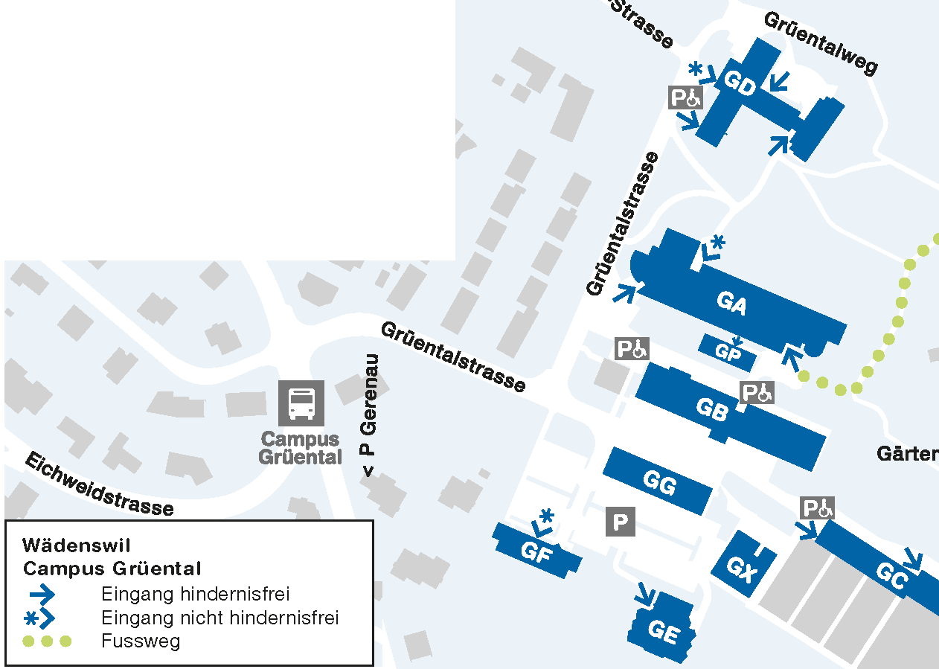
How to find us:
Bus stop «Wädenswil, Campus Grüental»
Parking spaces are available next to the building GG as indicated on the map.
Buildings:
Meeting in the auditorium in GA 203,
lunch in GD, group discussions in GA.
For further information, please contact Barbara Dold: lcaforum@ethz.ch

