82nd LCA Discussion Forum

Addressing the issue of plastic pollution:
status quo and the way forward

4 November 2022, ETH Zentrum campus, Room XYZ and online

We cordially invite you to the 82nd Discussion Forum on Life Cycle Assessment
The official language of this event is English
Due to its versatility and durability, plastic can be used for a plethora of purposes and the production and use of plastic products has been rising sharply since the middle of the last century. Unfortunately, not all of this plastic is managed appropriately at its end-of-life and ends up as non-degradable waste in the environment. The motives for this inefficient disposal of plastic polymers are multiple, but include mismanaged municipal solid waste and littering, but also weathering into tiny plastic fragments (e.g., tire abrasion or plastic particles washed through WWTPs). This has become an environmental issue concerning both our ecosystems and potentially also human health.
The field of life cycle assessment has only relatively recently begun to approach the issue of plastic waste, both in terms of required life cycle inventories and appropriate life cycle impact assessment models. Since 2017, when the Medellin Declaration urged the LCA community to address the impacts of plastic pollution, a dynamic research field with a large number of different research institutions involved globally has emerged. Large progress is being made in the development of impact assessment methods and approaches for inventory coverage in order to quantify and implement this aspect of plastic in the assessments.
This discussion forum will provide an overview of the current developments in the inclusion of plastic waste into life cycle assessment and give opportunities to discuss how to address these issues in a consistent way.

We look forward to meeting you in Zürich
Prof. Dr. Francesca Verones
Norwegian University of Science and Technology (NTNU)
Marthe Alnes Høiberg
Norwegian University of Science and Technology (NTNU)

Ass.Prof. Anne-Marie Boulay
CIRAIG, Canada

Ass.Prof. Ian Vázquez-Rówe
PUCP, Peru

Programme (*=online presentation)
 | Time |  | Speaker [Chair]
 | 08:15 | Registration
01 | 08:45 | A framework for addressing marine plastic pollution in LCA | Francesca Verones, NTNU
02 | 09:00 | Keynote: Addressing plastic pollution with a life cycle approach: an international perspective | Llorenc Mila I Canals, UNEP
A | Release of plastic waste into environmental compartments
03 | 09:25 | How to consider plastic leakage as a guiding principle for packaging ecodesign? | Anna Kounina, Quantis
04 | 09:45 | Microplastic fibres from textiles: emission routes, transport and environmental fate processes | Andy Booth, Sintef
05 | 10:05 | A methodology to account for plastic emissions and associated impacts from seafood supply chains. Application to French case studies | Philippe Loubet, U Bordeaux*
06 | 10:25 | PLASTEAX, a model and data repository for plastic end-of-life | Julien Boucher
 | 10:45 | Discussion
 | 11:00 | Coffee break
B | Fate: Transport, degradation, fragmentation and sinks of plastic litter in the environment
07 | 11:30 | Modeling of the fate of microplastics in the marine environment | Carla Hajjar*, CIRAIG
08 | 11:50 | LCA modelling of biodegradable plastic products in soil and sea environments – what data and fate information do we have vs what we need? | Cecilia Askham, NORSUS
09 | 12:10 | Nano- and microplastics policy: regulations and considerations for responsible and sustainable plastics use and development | Denise Mitrano, ETH
 | 12:30 | Discussion
 | 12:45 | Lunch
C | Short presentations
10 | 13:45 | Short presentations (7-10 min each, depending on submissions)
D | Exposure and Effects
11 | 14:15 | Accounting for impacts of macroplastic debris in Life Cycle Assessments | Marthe Høiberg*, NTNU
12 | 14:35 | New characterization factors for microplastic emissions of 9 polymers in the marine environment | Elena Corella-Puertas*, CIRAIG
13 | 14:55 | Development of an effect factor for marine plastics’ impact on marine carbon sequestration | Fei Song*, NTNU
 | 15:15 | Coffee break
14 | 15:45 | Characterization of human exposure and health effect of microplastic and their encapsulated chemicals | Olivier Jolliet*, DTU
15 | 16:05 | Learnings from Case study applications integrating microplastics impacts in LCA, from the UN SUPP Report | Anne-Marie Boulay*, CIRAIG
16 | 16:25 | The connection between waste dissipation and resource depletion from an LCIA perspective | Diana Ita*, PUCP
 | 16:45 | Discussion
E | Synthesis and Conclusion
17 | 17:00 | Synthesis and conclusions of the day | Anne-Marie Boulay/Francesca Verones
 | 17:15 | End of 82th LCA Forum

Practical information
Registration open until xxxx
Please use the following link:
https://ethzurich.eventsair.com/lca-2022/df82/Site/Register
To register you need to create a profile, which is done in very few steps and is self-explanatory. In case you are not able to pay by credit card, please send an e-mail to:
lcaforum@ethz.ch with a short notice that you want to receive an invoice instead. Please provide the full invoice address as well as the chosen fee type.
For all questions regarding the registration process, please do not hesitate to contact:
lcaforum@ethz.ch
Covid-19
To be adjusted ...
Lunch
Lunch will be served close to the location. A vegetarian meal option is always on offer.
Location
The DF will take place in the room XYZ, at Campus ETH Zentrum, ETH Zurich, Rämistrasse 101, 8092 Zurich (see map below). From the main train station, cross the river Limmat and use the "Polybahn" cable car.
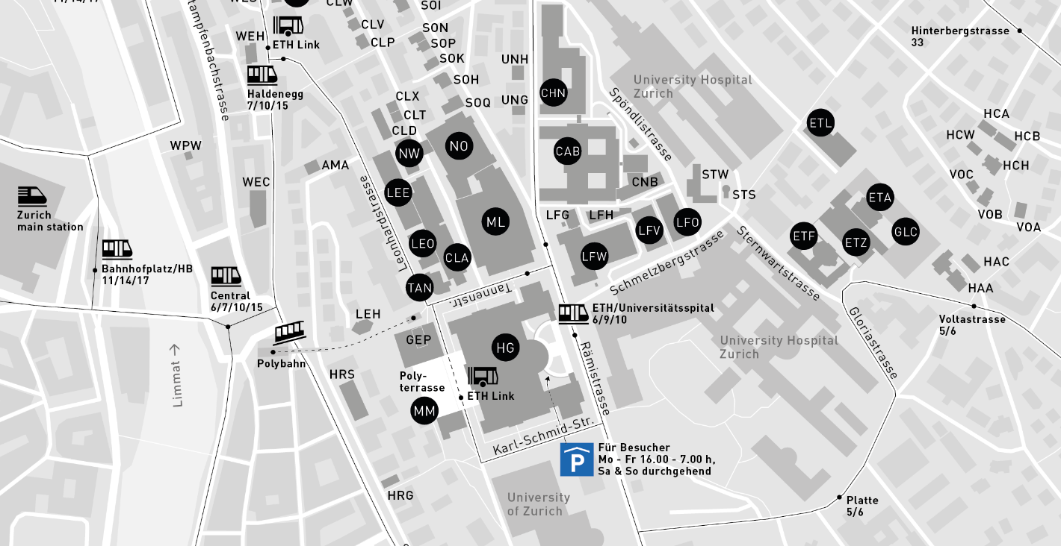
For further information, please contact Barbara Dold: lcaforum@ethz.ch

